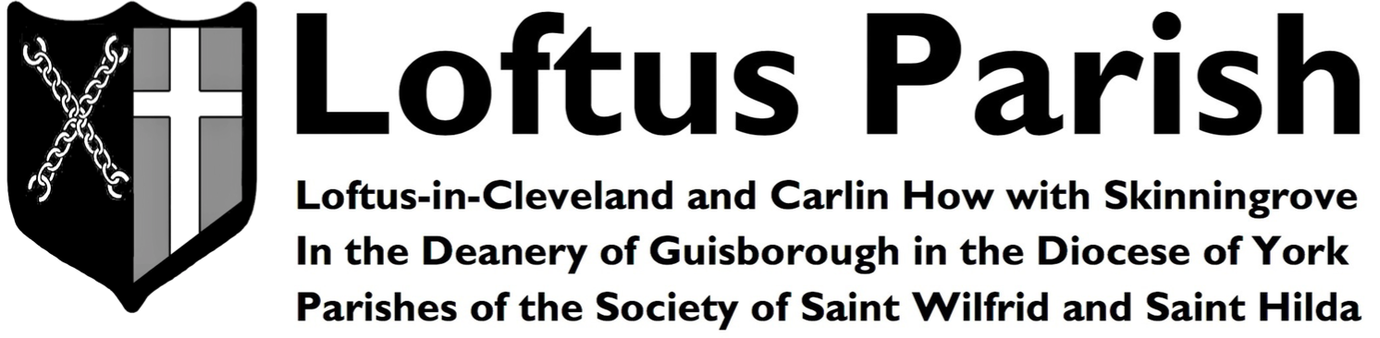 |  |  |  | Seventh after Trinity  Sunday 30th July 2017  Ordinary Time
Sunday | 30th | THE SEVENTH SUNDAY AFTER TRINITY  17th Week of Ordinary Time | 9:00 am  10:30 am  10:30 am  6:00 pm |  | Parish Mass  Parish Mass  Sunday School  Evening Prayer | St Helen’s  St Leonard’s  Town Hall  St Leonard’s
Monday | 31st | Saint Ignatius Loyola | --- |  | --- | ---
Tuesday | 1st | Saint Alphonsus | 7:45 pm |  | Bible Study | St Leonard’s
Wednesday | 2nd | Saint Euesebius | --- |  | --- | ---
Thursday | 3rd | Feria | --- |  | --- | ---
Friday | 4th | Saint John Vianney | --- |  | --- | ---
Saturday | 5th | Feria | --- |  | --- | ---
Sunday | 6th | THE FEAST OF THE TRANSFIGURATION OF THE LORD  18th Week of Ordinary Time | 9:00 am  10:30 am  10:30 am  12:30 pm  6:00 pm |  | Parish Mass  Parish Mass  Sunday School  Baptism  Evensong | St Helen’s  St Leonard’s  Town Hall  St Leonard’s  St Leonard’s
At the Sunday Parish Mass
Our hymns are taken from…The English Hymnal
Introit Hymn | Offertory Hymn | Post Communion | Recessional Hymn
466 | 504 | 302 | 398

We pray for the sick and for those who care for them, praying especially at this time for…
Carrie Anne Barnes, Baby Zachary James Conroy, Raymond Conn, Andrew Downs, Marjorie Downs, Marie Downs,
Irene Duck, Myrtle Fishlock, Andy Harrison, Fr Valerie Haynes, Eileen Henderson, Margaret Hodge, Allan Howard,
Brenda Lightfoot, Leigh Marshall, Betty Pennock, Jack Robert, Lillian Swallwell, Fr Edmund Wheat,
Chloe Whitney & Keith Wilcox

We pray for those who have recently died and especially for…
We pray also for those whose anniversaries of passing take place at this time of the year and especially for…Leonard Edwin, Christopher Hoggarth, Thomas Locker, John Blenkin, Nigel Downs, Diana Yates,
Ethel Larke & Jack Maughan

An “August Special Events Flyer” is now available! There are four special events this August:

- The East Cleveland Walsingham Cell Assumption Day Mass on Tuesday 15th August 2017, 7:00 pm
at All Saints’ Church in Skelton.
- Saint Helen’s Day Patronal Festival on Friday 18th August 2017, 7:00 pm at Saint Helen’s Church Carlin How.
- The Annual Parish Picnic Sunday 20th August 2017 from 1:00 pm at the Danby Moors Centre.
- And a joint Safari Supper with friends from Saint Margaret’s Brotton on Friday 25th August 2017!

