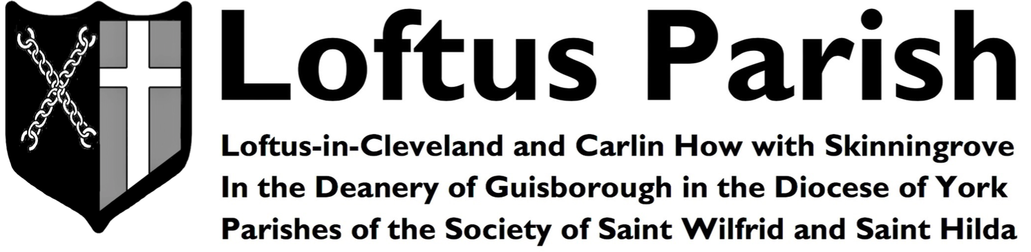 |  |  |  | Harvest Festival Sunday  1st October 2017  Ordinary Time
Sunday | 1st | HARVEST  FESTIVAL  SUNDAY  26th Week of Ordinary Time | 9:00 am  9:15 am  10:30 am  10:30 am  6:00 pm |  | Parish Mass  Choir Practice  Parish Mass  Sunday School  Evensong | St Helen’s  St Leonard’s  St Leonard’s  Town Hall  St Leonard’s
Monday | 2nd | Holy Guardian Angels | 10:00 am  7:30 pm |  | Prayer Book Mass  Deanery Synod | St Leonard’s  St Peter’s Redcar
Tuesday | 3rd | Feria | 7:00 pm  7:45 pm |  | Mass  Bible Study | St Leonard’s  St Leonard’s
Wednesday | 4th | St Francis of Assisi | 10:00 am |  | Mass | St Helen’s
Thursday | 5th | Feria | --- |  | --- | ---
Friday | 6th | Feria | 5:30 pm  7:30 pm |  | Choir Open Evening  Sixties Night | St Leonard’s  Town Hall
Saturday | 7th | Feria | --- |  | --- | ---
Sunday | 8th | SEVENTEENTH  SUNDAY  AFTER TRINITY  27th Week of Ordinary Time | 9:00 am  9:15 am  10:30 am  10:30 am  12:30 pm  6:00 pm |  | Parish Mass  Choir Practice  Parish Mass  Sunday School  Baptism  Evensong & Benediction | St Helen’s  St Leonard’s  St Leonard’s  Town Hall  St Leonard’s  St Leonard’s
At the Sunday Parish Mass

Our hymns are taken from…Celebration Hymnal for Everyone

Introit Hymn | Offertory Hymn | Post Communion | Recessional Hymn
136 | 14 | 178 | 782

We pray for the sick and for those who care for them, praying especially at this time, for…
Carrie Anne Barnes, Andrew Downs, Marjorie Downs, Marie Downs, Irene Duck, Myrtle Fishlock,
Andy Harrison, Fr Valerie Haynes, Eileen Henderson, Margaret Hodge, Allan Howard, Lillian Johnson, Brenda Lightfoot,
Leigh Marshall, Betty Pennock, Jack Robert, Lillian Swallwell, Fr Edmund Wheat, Chloe Whitney & Keith Wilcox

We pray for those who have recently died and we pray also for those whose anniversaries of passing take place at this time of the year and especially for…
Vera Beaumont, Betty Amelia, Barbara Atkinson, Joseph Henry Lindsley, Colin Marshall, Evelyn Maud Greenwood, David Huddleston & Brenda Chapman

